
a
Company
Logotype

Cone Beam Computed Tomography- Report



Porur Dental X-rays & CBCT

Patient Name : Mrs. Arul Venkatesan | Date of Report : 13.06.2024
Age/ Gender : 54 years/ Female | Region of Interest : CBCT Maxilla Mandible
Referring doctor: Dr. Nethaji. V | Indication : Implant assessment
Clinical Notes: Nil
PATIENT INFORMATION

CBCT- Maxilla Mandible provided
CBCT – IMAGE DETAILS

RADIOGRAPHIC INTERPRETATION

- Completely missing crown and root structure in relation to 15, 36, 37, 38.
- The occlusal plane of 17, 18 is lower when compared to 16 suggestive of supra-eruption.
- The maxillary alveolar ridge is present with normal trabecular pattern.
- Presence of mucosal thickening in relation to the floor of the right maxillary sinus is evident.

IMPLANT ASSESSMENT

 | 15 region | 16 region | 17 region
Sub-Crestal (in mm) | 3.72 | 11.28 | 1.95
Mid- Crestal (in mm) | 4.82 | - | -
Distance between the alveolar ridge and floor of the maxillary sinus (in mm) | 3.43 | 2.99 | 9.09

 | 36 region | 37 region
Sub-Crestal (in mm) | 5.08 | 5.74
Mid- Crestal (in mm) | 8.8 | 8.81
Distance between alveolar ridge and the inferior alveolar nerve canal (in mm) | 15.24 | 16.48
Distance between alveolar ridge and the inferior border of mandible (in mm) | 26.44 | 25.08

RADIOGRAPHIC IMPRESSION

- Partially edentulous maxillary and mandibular alveolar ridge.
- Right maxillary sinusitis.

Kindly correlate with clinical findings


IMAGES FOR REFERENCE

RECONSTRUCTED PANORAMIC VIEW
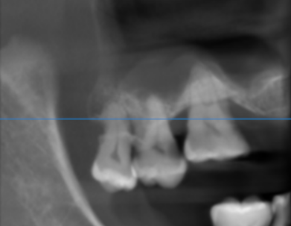

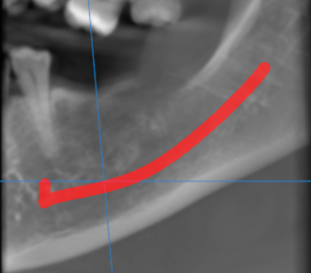

3-DIMENSIONAL VIEW

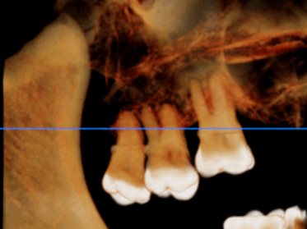

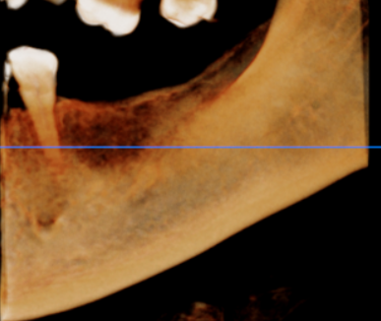

CROSS SECTIONAL VIEW

15 region | 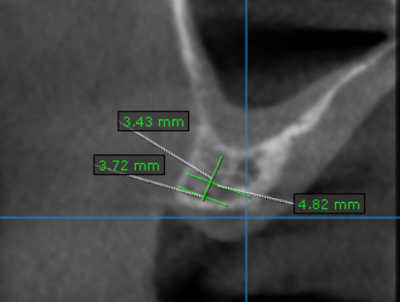
16 region | 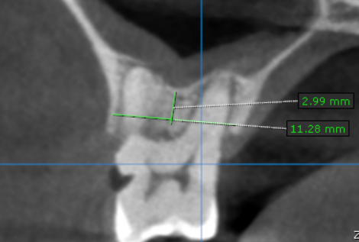
17 region | 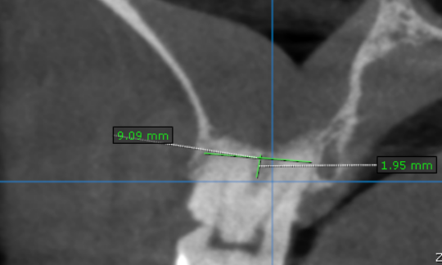
36 region | 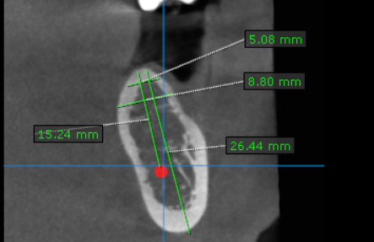
37 region | 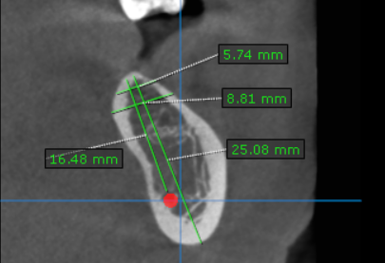

**** End of report ****

